7COM1079-0901-2025 - Team Research and Development Project

Final report title: Is there a relationship between the rise of global population and CO2 emissions per capita between 1983 and 2008?

Group ID: B97

Dataset number: DS230

Prepared by: Jessica Healy 21050775,
Tanjim Azad Chowdhury 18057708
Andrei-Sorin Filipoi 21052297
Ebubechukwu Nwachukwu 20033198
John Afolabi 21039661

University of Hertfordshire
Hatfield, 2025

Contents:
1. Introduction: 3
1.1 Problem statement and research motivation 3
1.2 The data set 3
1.3 Research question 3
1.4 Null hypothesis and alternative hypothesis (H0/H1) (100 words) 3
2. Background research: 3
2.1 Research papers (at least 3 relevant to your topic / DS) (200 words) 3
2.2 Why RQ is of interest (research gap and future directions according to the literature) (100 words) 3
3.Visualisation: 4
3.1Appropriate graphs for the RQ 4
3.2 Additional information relating to understanding the data (optional) 4
3.3 Useful information for the data understanding 4
4. Analysis: 5
4.1 Statistical test used to test the hypotheses and output 5
4.2 The null hypothesis is rejected based on the p-value 0.01967. 5
5. Evaluation – group’s experience at 7COM1079: 6
5.1 What went well 6
5.2 Points for improvement 6
5.3 Group’s time management 6
5.4 Project’s overall judgement 6
5.6 Comment on the GitHub log output 6
6. Conclusions: 7
6.1 Results explained (75 words) 7
6.2 Interpretation of the results (75 words) 7
6.3 Reasons and/or implications for future work, limitations of your study (50 words) 7
7. Reference list: 8
8. Appendix: 9

1. Introduction:

1.1 Problem statement and research motivation
Global carbon emission rates have substantially increased over recent decades, raising major concerns regarding its impact on climate change. Although it is thought that emission rates tend to rise as the global population grows, the direct relationship between the two is not the only contributing factor. CO2 emissions per capita are also influenced by industrial developments, energy use and technological progress, all of which have rapidly evolved between 1983 and 2008. Understanding whether the rise in population is directly related to the changes in CO2 emissions in critical for this study and we aim to investigate this through the use of R studio to analyse the dataset we have been given.

1.2 The data set
The dataset used in this study spans the years 1983 to 2008 and includes annual global rates relevant to climate and atmospheric conditions. Variables include global population, CO2 emissions per capita, greenhouse gas emissions, temperature anomalies, aerosol levels and solar irradiance. This dataset allows for quantitative analysis of long term environmental trends.

1.3 Research question
This study investigates whether global population growth is associated with changes in CO2 emissions per capita between 1983 and 2008. By examining these two continuous variables over time, the aim of this research is to determine whether a measurable statistical relationship exists and whether the increased population correlates with the increased carbon emission rates.

1.4 Null hypothesis and alternative hypothesis (H0/H1) (100 words)
To investigate whether global population growth is associated with changes in CO2 emissions per capita between 1983 and 1008, we have come up with two hypotheses. The null hypothesis H0 states that there is no monotonic association between global population and CO2 emissions per capita, as the p value equals 0. The alternative hypothesis instead suggests that a monotonic association does exist between the two variables, as the p value is higher that 0. These hypotheses provide the basis for a statistical analysis to take place to determine whether or not population growth is directly associated with the changes in CO2 emissions.

2. Background research:

2.1 Several studies have explored the relationship between population growth and carbon dioxide (CO₂) emissions, particularly in the context of global environmental change. Shi (2003) examined global data over several decades and found that population growth is positively associated with increases in CO₂ emissions. However, the study also noted that per capita emissions are strongly influenced by factors such as economic development and energy consumption, suggesting that population size alone cannot fully explain emission trends.

Dietz and Rosa (1997) investigated environmental impact using the IPAT framework and international datasets. Their results showed that population size plays a statistically significant role in driving environmental pressures, including CO₂ emissions. Nevertheless, their analysis focused mainly on total emissions rather than emissions per capita, which limits its usefulness when assessing individual-level emission behaviour.

More recent research by Martínez-Zarzoso et al. (2017) analysed global panel data and concluded that technological progress and improvements in energy efficiency can reduce CO₂ emissions per capita, even as population increases. While this study provides valuable insights, its reliance on complex econometric modelling makes it difficult to directly observe simpler monotonic relationships between population growth and per-capita emissions.

Overall, the literature suggests that population growth contributes to CO₂ emissions, but its direct relationship with emissions per capita remains less clearly defined, justifying further investigation using datasets such as DS230.

2.2 Fewer studies explicitly examine the relationship between world population size and CO2 emissions per capita during a specified historical time, despite the fact that previous data demonstrates that population expansion influences global CO2 emissions. A large portion of the literature either focuses on overall emissions (Dietz and Rosa, 1997) or includes other economic factors that could obscure straightforward correlations (Martínez-Zarzoso et al., 2017). Because it uses a non-parametric statistical approach to investigate a direct and obvious relationship, this research subject is of interest. In addition to providing a foundation for future research that takes into account other factors like energy use, industrial activity, and climate policy, filling this gap helps determine whether population growth alone is linked to changes in per-person emissions.

3.Visualisation:

3.1Appropriate graphs for the RQ
Due to both variables constantly changing over time, a line graph was implemented to examine the link between .The graph shows the trends and joint movement of the two variables. A histogram graph was also implemented to show the overall distribution of co2 emission per capita.

3.2 Additional information relating to understanding the data (optional)
The line graph shows the consistent growth of population, while co2 emission per capita fluctuates with a slight upwards trend. The histogram graph shows that most co2 emission values sit around 4.1 to 4.4 range. These graphs help in assessing whether the rise in population corresponds with distinct shifts in carbon output per person.

3.3 Useful information for the data understanding
The population between the years 1983 and 2008 steadily rose, but the co2 emissions per capita rose slightly, suggesting it is a weak direct relationship. The emission of carbon per person remains stable despite the growth of population. This shows that there are other factors which may influence per capita emission more strongly than just population.
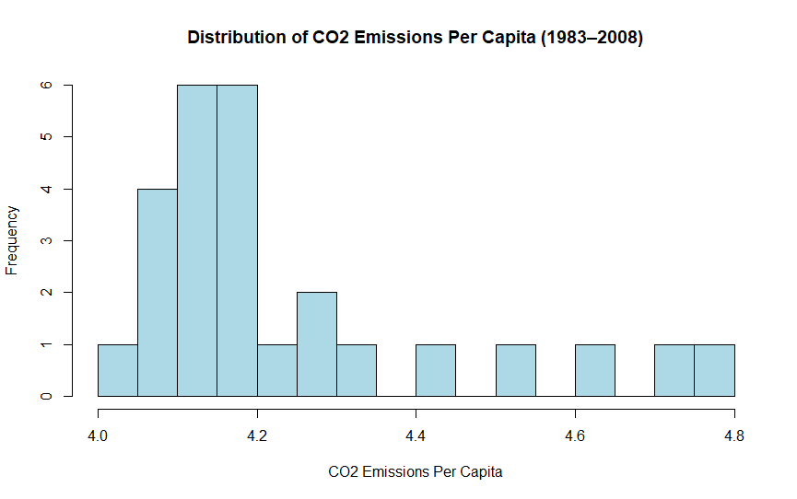
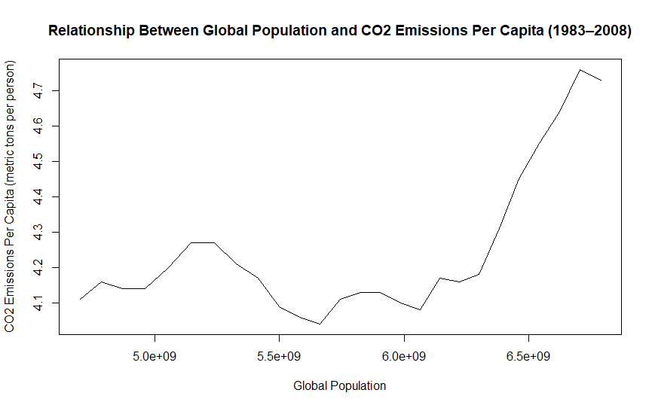

4. Analysis:

4.1 Statistical test used to test the hypotheses and output
We chose Spearman’s rank correlation because our research question examines whether two continuous variables, global population and CO₂ emissions per capita, are associated. The histogram of CO₂ emissions per capita showed a non-normal distribution, violating the assumptions of Pearson’s correlation. Spearman’s rho does not assume normality and assesses monotonic relationships using ranks, making it appropriate for our data and research question. This ensures the statistical test validly evaluates whether population changes relate to per-capita emissions.

4.2 The null hypothesis is rejected based on the p-value 0.01967.
It gives Spearman’s rank correlation coefficient (ρ): 0.4545
Test statistic (S): 1595.6
Alternative hypothesis: true ρ ≠ 0
Since the test produced a p-value of 0.01967, which is below the standard threshold of 0.05, the result is considered statistically significant, allowing us to reject the null hypothesis that there is no association between global population and CO₂ emissions per capita. The positive correlation suggests that, over the period from 1983 to 2008, as the global population grew, per-person CO₂ emissions tended to rise as well. It is important to note that this relationship does not demonstrate cause and effect; rather, it indicates a meaningful link between population size and average emissions.

5. Evaluation – group’s experience at 7COM1079:

5.1 What went well
I believe that our group has successfully managed to not only collaborate effectively by distributing tasks among ourselves and provide help between us when needed but also maintain seamless communication throughout the whole timeframe of the project, by carefully analysing the dataset and using statistical tools to create graphs, which allowed us to easily draw conclusions related to our research question. GitHub also made it easier to share resources and keep track of changes.

5.2 Points for improvement
While we managed to complete the project on time and allowed plenty of time at the end for some final touches, I consider we could have managed our time more efficiently, especially in the early planning stages when tasks were not fully understood. The group had couple of meetings, however more frequent meeting would have ensured better time management and understanding of the project’s tasks. Better planning would have definitely resulted in less stress and pressure close to the deadline.

5.3 Group’s time management
Like I said previously, towards the end of the project, members contributed more consistently, but early planning could have been improved. Work tended to accumulate closer to deadlines, which caused some stress, however we have managed to complete all tasks in time, with increased coordination in the final stages.

5.4 Project’s overall judgement
Overall, I believe the project has been a complete success by carefully choosing our research question, doing appropriate research on both the dataset and external sources related to the subject. The group produced a complete report, including visualisation, analysis, and interpretation with a clear answer to the research question.

Note any changes to group since original allocation if applicable. Add new or amended GitHub Ids for new members
N/A

5.6 Comment on the GitHub log output
The GitHub logs in Appendix B show consistent contributions from the group. Commits demonstrate progress in writing the report, uploading R scripts, and correcting formatting. Tracking versions allowed us to revert errors when needed. As a result, the logs reflect seamless teamwork and incremental development of the project.

- Most important GitHub commits:

1.Changing values for graphs - Updated histogram breaks from 10 to 20 for better visualization.

2. R Script for each graph created for dataset - vital to answer the research question and conduct proper analysis

3. Fixed punctuation - allows for better reading of the word document for the examiner.

6. Conclusions:

6.1 Results explained (75 words)

6.2 Interpretation of the results (75 words)
- Interpretation of what the results mean in terms of your RQ and the effect this may have on your population and the wider context of your topic.

6.3 Reasons and/or implications for future work, limitations of your study (50 words)

7. Reference list:
1) From LibreTexts (Spearman Rank Correlation explanation)
LibreTexts (2024) 5.2: Spearman Rank Correlation. Available at: https://stats.libretexts.org/Bookshelves/Applied_Statistics/Biological_Statistics_%28McDonald%29/05%3A_Tests_for_Multiple_Measurement_Variables/5.02%3A_Spearman_Rank_Correlation?utm_ (Accessed: 12 December 2025).

2) From Laerd Statistics (guide on Spearman’s Rank Order Correlation)
Laerd Statistics (no date) Spearman’s Rank-Order Correlation. Available at: https://statistics.laerd.com/statistical-guides/spearmans-rank-order-correlation-statistical-guide.php?utm_ (Accessed: 12 December 2025).

3) From NU Resources (Spearman’s correlation info)
NU Resources (no date) Spearman’s Rank Correlation. Available at: https://resources.nu.edu/statsresources/Spearmans?utm_ (Accessed: 12 December 2025).

4) University of Hertfordshire (2025) Instructions for the Research Question Demos [online] Hertfordshire Canvas. Available at: https://herts.instructure.com/courses/124322/files/12266164?module_item_id=4790095 (Accessed: 10 December 2025).
5) University of Hertfordshire (2025) Instructions for Visualisation and Analysis Demos. [online] Hertfordshire Canvas. Available at: https://herts.instructure.com/courses/124322/files/12336660?module_item_id=5326725 (Accessed: 12 December 2025 ).
6) Goncharenko, J. and Noll, J. (2025). Introduction to Statistics[online] Hertfordshire Canvas. Available at: https://herts.instructure.com/courses/124322/files/11217728?module_item_id=4790054 (Accessed: 7 December 2025).

7)Shi, A. (2003) The impact of population pressure on global carbon dioxide emissions, 1975–1996: evidence from pooled cross-country data. Available at: https://doi.org/10.1016/S0921-8009(02)00223-9 (Accessed: 12 December 2025). Demographic Research+1
8)Dietz, T. and Rosa, E.A. (1997) Effects of population and affluence on CO2 emissions. Available at: https://doi.org/10.1073/pnas.94.1.175 (Accessed: 12 December 2025). PNAS+1
9)Martínez-Zarzoso, I., Bengochea-Morancho, A. and Morales-Lage, R. (2006) The impact of population on CO2 emissions: evidence from European countries. Available at: https://doi.org/10.2139/ssrn.902703 (Accessed: 12 December 2025). growkudos.com+1

8. Appendix:
R code snippet used for analysis:
# Run a Spearman rank correlation test between
# global population and CO2 emissions per capita

# Perform the Spearman correlation test
model <- cor.test(
carbon_segment$Population, # independent variable
carbon_segment$CO2emissionspercapita, # dependent variable
method = "spearman" # use non-parametric Spearman’s rho
)

# Display the results of the test
print(model)

GitHub log output:

